H.T No
Regulations:
A18

Sreenidhi Institute of Science and Technology
(An Autonomous Institution)
Code No: 7HC16 Date: 28-Dec-2022 (FN)

B.Tech II-Year II- Semester (A18) Special Supplementary Examination - December-2022
MATHEMATICS-II (DIFFERENTIAL CALCULUS) (CSE, IT and ECM)

Time: 3 Hours Max.Marks:70

Note: a) No additional answer sheets will be provided.
b) All sub-parts of a question must be answered at one place only, otherwise it will not be valued.
c) Missing data can be assumed suitably.

ANSWER ANY 5 OUT OF 8 QUESTIONS. EACH QUESTION CARRIES 14 MARKS.

Bloom's Cognitive Levels of Learning (BCLL)
Remember | L1 | Apply | L3 | Evaluate | L5
Understand | L2 | Analyze | L4 | Create | L6

 |  |  | BCLL | CO(s) | Marks
1. | a) | If 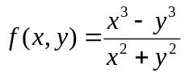 when x ≠ 0, y ≠ 0 and f(x,y) = 0 when x = 0, y = 0. Find out whether the funcion f(x,y) is continuous at origin. | L2 | CO1 | [7M]
 | b) | Discuss the maxima and minima of f(x, y) = x² + y² + 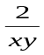. | L3 | CO1 | [7M]
2. | a) | Solve (y⁴ + 2y)dx + (xy³ +2y⁴ – 4x) dy = 0 | L3 | CO2 | [7M]
 | b) | If 30% of a radioactive substance disappears in 10 days, how long will it take for 90% of it to disappear. | L3 | CO2 | [7M]
3. | a) | Solve (D² + 2D + 2) y = sin 2x | L3 | CO3 | [7M]
 | b) | Apply the method of variation of parameters to solve 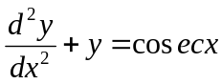. | L3 | CO3 | [7M]
4. | a) | Consider the following data for g(x) = sinx / x.  Find g(0.45) using Newton Backward interpolation. | L2 | CO4 | [7M]
  X | 0.1 | 0.2 | 0.3 | 0.4 | 0.5
  G(x) | 9.9833 | 4.9696 | 3.2836 | 2.4339 | 1.9177
 | b) | Using Lagrange’s interpolation formula, find y corresponding to x = 10. | L2 | CO4 | [7M]
  x | 5 | 6 | 9 | 11
  y | 12 | 13 | 14 | 16
5. | a) | Compute y(0.1) by Taylor series method if y¹ = y + xy², y(0) = 1. | L3 | CO5 | [7M]
 | b) | Given 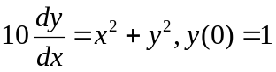. Use Runge-Kutta 4th order method to find y(0.2) with step size h = 0.2. | L3 | CO5 | [7M]
6. | a) | Find 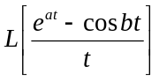 | L2 | CO6 | [7M]
 | b) | Find 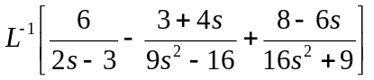 | L2 | CO6 | [7M]
7. | a) | If x + y + z = u, y + z = uv, z = uvw, then evaluate 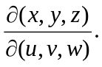 | L2 | CO1 | [7M]
 | b) | Solve 2xy dy – (x² – y² + 1) dx = 0 | L3 | CO2 | [7M]
8. | a) | Make use of Newton-Raphson method to find a real root of the equation  x³ -19 =0 correct upto three decimal places with initial approximation as x₀=2. | L2 | CO4 | [5M]
 | b) | Given 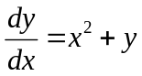, y(0)=1. Evaluate y(0.02) using Euler’s method.  [ Take h = 0.02 ] | L2 | CO5 | [5M]
 | c) | Use convolution theorem to find 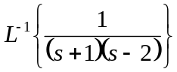 | L3 | CO6 | [4M]

-- 00 -- 00 –

